Ruahine User’s Group Meeting
2 March 2020
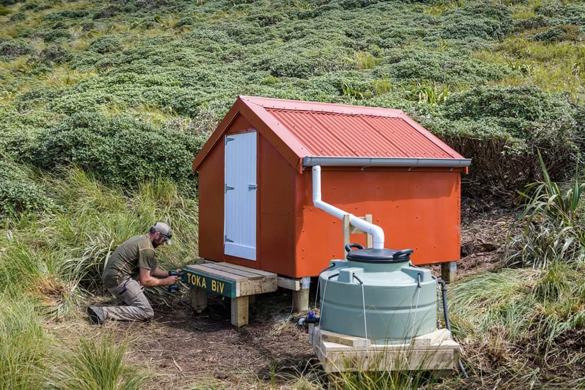

The new and improved Toka Biv
Actions from this meeting
- Action – Dan to capture this work in the system - Skylight needs fixing in Awatere Hut. Done
- Action – Mike Charlton has offered to fix the Awatere Hut skylight, Shaun to work with Mike Charlton to supply materials to fix Done fixed by John M and Dan E
- Action - for group, have a chat to your groups about potential projects that could be done through the BCT. John Beech is compiling a list of potential projects that have been put forward by the group.
- Action for DOC to contact the farmer about access/locked gate at Master Road
- Action – for group - If anyone has any suggestions or comment about the proposed Sunrise carpark upgrade and/or what to do with the closed Coppermine tracks, please email Dan dtuohy@doc.govt.nz
- Mike Charlton to talk to Ken Mills (Kaiapoi) to see if he has a spare part for the Barlow Hut cooker.
Attendance: Matt Short Hastings NZDA, John Beech MTSC FMC, Mike Charlton Ruahine NZDA, Dave Muliner HTC, Murray Alderson HTC, John Montgomery HTC, Dan Elderkamp CHB F&B W Cons Board, Janet Wilson RWP PNTMC, Warren Wheeler PNTMC, Vince Payne Ruahine NZDA, Ian Patterson Manawatu NZDA, Moana Smith-Dunlop DOC, Cherry Peeti-Taparau A frame community group, Wai Taparau A Frame community group, Shaun Ruddle DOC.
Welcome & introductions
- Apologies: Steve and Toni Bailey Kelly Knight Community Group, Julia Mackie NTC.

- Minutes from previous meetings & actions arising
  - Action DOC: John and Shaun to catch up over Stewardship Land Status. Complete.
  - Action DOC: Smith Stream water tank alert status. This is no longer in action and has been remedied by DOC Dec 19.
Recreation and Historic
- Huts and Shelters – work undertaken and planned

- DOC managed

    - Completed
- Sunrise hut.
  - An issue with the spouting on the hut made the collection system unable to operate effectively. The hut tanks were unable to fill properly and were empty. The team fixed the guttering and topped up the water tanks to tie the hut over to the next rain.
  - Prior to the water supply issue at the hut, the team were plotted to spend 4 days at the hut in Feb to complete a detailed hut servicing trip. This was moved due to a commitment to FENZ for Fire support.
  - The next trip to the hut is plotted for March. It will involve the removal of old track maintenance gear, hut clean, completion of existing work orders, woodshed top up, and some future work scoping.
  - The hut warden has been up at the hut over the booking season.

- Rangiwahia hut.
  - Requires a firewood top up prior to winter.
  - Looking to fly in some new seats along with a second picnic table with firewood.
  - The seat at the camping site is being scoped to be re-positioned to a more scenic viewing area near the same location.
  - Monthly hut checks completed.

- Longview Hut.
  - Requires a firewood top up prior to winter. Is getting reasonably low.
  - External shed has had the door ripped off by suspected wind or vandalism.
  - Monthly hut checks completed. Was missed in Dec/Jan due to high winds when these were plotted.
  - Warren reported the door handle is loose, potentially replace the whole handle
  - Questions was asked around the painting of this hut. Mike C asked if the hut was due for painting. DOC explained it is needed, however other work is taking precedence with funding and staff capacity.

- Iron Gate Hut.
  - Continued to support the construction task with weekly flights and project input.
  - Hut completed in December and site/final work completed in January.
  - The District completed a final sweep of work at the site in January.
  - Dan E reported that the corrugated foam is dripping out of front window under the deck
  - Janet praised DOC for the new hut, but questioned the design of the new drying rack
  - Shaun spoke about how it was cool to get together and talk about the construction of the hut. NZDF absolutely loved the construction and are looking for some more work. They got good praise for the public sign telling about the hut construction. Shaun explained how it was great to work with RUG regarding the hut design and capture some of the ideas from a separate smaller RUG meeting. NZDF were an integral part of the project and worked professionally to deliver a great project.
  - Shaun briefly talked about why the hut got replaced due to wetness in the walls and how it was funded through the DOC Community Fund fund due to the NZDF doing the job and user groups. Shaun also explained the history behind the project and how the hut came about being replaced.
  - Shaun mentioned that the farmer nearest the Patterson Road end, Chris Drew kindly allowed DOC to fly from their fertilizer bin. This was a great contribution to the project. Janet Wilson also allowed some flights from her property, a big thanks for allowing that also.

- Pohangina Base.
  - General site maintenance and accommodation tidy up.
  - Question was raised about the popularity of this base, Shaun said that usage has picked up. The RUG asked how popular the Pohangina Base facility was over the last year. DOC reported it is receiving regular use and is reasonably busy during the summer period. It has been worthwhile having it on the online booking system.

- Smith’s Stream Hut.
  - Water tank cleaned and flushed due to dead rats.

- Barlow Hut.
  - Corker cooker needs fixing due to a crack in the top. Is anyone aware of any spare parts or repair methods?
  - Mike Charlton to talk to Ken Mills (Kaiapoi) to see if he has a spare part for this

- Triplex Hut
  - Spouting cleaned out and general hut tidy completed.

- Waterfall Hut
  - Fireplace lintel was burnt/charred. Required a stainless surround to be installed.

- Hut issues
  - A lot of rubbish accumulating in some huts. Especially McKinnon and Waterfall.
  - Curtains in Huts. Please do not put curtains in huts. These are a fire risk and need to be removed. This causes DOC Rangers to use their time removal curtains versus other needed work.
Planned next 3-4 Months
  - Continue Serviced Hut visits.
  - Sunrise, Rangiwahia and Longview hut’s maintenance and firewood top up.
  - Potential visit to Top Maropea hut for Historic maintenance.
  - Complete reactive work if the safety to users becomes an issue.
Historic Huts
Mike C put the motion forward to add a dog box bivvy to our historic portfolio. Shaun explained the process behind having something added to the portfolio including a form of an application process. Mike C will arrange a discussion with DOC around which bivvy to put forward as historic. Dan T will have a chat to the Heritage and Visitor Team and seek further information around this process.
- Toka, Taruarau Biv, Tarn Ridge
Awatere Hut
Action – Dan to capture this work in the system - Skylight needs fixing in Awatere Hut, it’s just polycarbonate
- Community managed
    - Completed
  - Cherry Peeti-Tapurau and her team have started work on A Frame Hut.
  - Josh Murray, and friends refurbished Toka Bivvy with support from BCT and Rob Brown.
  - Progress on A Frame scraped down the exterior and painted the ceiling and part way down the walls. Still to install the roof and water tank, and toilet. Need to replace a lot of the rot in the walls before installing the new roof. They are up there most weekend and making good progress.
  - Shaun praised Josh and for the work completed at Toka Biv. There is a you tube clip on this under .308. Rob from BCT helped out heaps on this work which made the job easier for Joshua and co. Rob is quite keen to get more of this work going, funding round closes and of Feb. Question was raised around Sparrow hawk biv from John Beech, no plans as yet to do, but this can be looked into. All you need to do a hut is a good keen crew and Rob will give you plenty of support. Question was raised about Diggers Hut rebuild, not at this stage and the bed nights for the hut might not warrant it.
  - John B asked about a hut in the Kaweka Forest Park and Moana will put him in touch with Napier office
  - Top Gorge, requires a couple of mattress covers
  - Heritage has some work done on it by the club, water tanks checked, tec screws, done some rat control
  - Janet talked about Mid Poh and Ngamoko and all looks fine. Thinking about making the fire easier to cook on. Talked about the Leon Kinvig fire being terrible
  - Waikamaka Hut looking good, Howlett’s internal being painted soon. All chairs have been vandalized. There are parties going in their next month and they will take in some vinyl and rubber for the chairs and some bags of coal. The cost is in the mid $90 to fly bags of coal in.

- Tracks and roads
- DOC managed
    - Completed
  - Manawatu Gorge and local reserve walking tracks maintained.
  - Maintaining front country track vegetation.
  - Sunrise Carpark still in design phase.
  - Coppermine, closed tape is being ignored. Shaun talked about the fact of only having 3 rangers and the Iron gate hut build taking a lot of time. Moana talked about opening track where we know there is a known slip. If we close a track because of this we are telling the public not to go due to the risks, the public will then go at their own risk. Mainly aimed at the not so experienced back country tramper who doesn’t know any better. John B wants to know what the timeline is to get it fixed. Moana said that there is a desire to do something but with funding and resourcing the way it is the timeframe is unknown. There did used to be a sign in place informing of slips and experienced parties only. Different people think of experienced in different ways. Cherry talked about members of the groups doing some track rerouting and marking on these closed tracks. Question was asked what is takes to re-open a closed track. Moana said it takes quite a lot of work to re-open a track. Now the Coppermine is not a priority to re-open.
  - Sunrise carpark was talked about and the design was discussed. If you have any comments or thoughts, please send these through to Dan.
- Planned next 3-4 Months,

      - Kashmir Road grade tidy up and grade.
      - No Mans Road work scoped and delivered.

- Access
  - Mokai Te Matea station situation is yet to be resolved. Dan and Nobby met with station owner for introductions and a plan to regularly meet to enhance relations. Also met with the Ross’s (neighboring station) to discuss fencing around the DOC carpark on Mokai station, currently closed)
  - Parks Peak Station access no longer requires calling the landowner. Signed access will be established in November. Please park in area provided in the map.
  - Mid Pohangina access through the private access point is now closed to public. This is due to illegal hunting activities happening on the farm with loss of stock. A new system is yet to be decided with the landowner for access. In the meantime, contact must be made with the landowner for access permission.
  - Kawhatau access, currently working with Peter Daly to build a relationship and look at options for access. One option is a track through Rangitane SR down to the river and then up the river. Not official yet but working on it.
  - Dan will be taking on the access portfolio and is currently working around the various access points to meet the landowners. Masters shelter has had the gate locked due to bad company going to the shelter. Action for Dan to contact the farmer about this access.

Biodiversity

Completed
- Rat/possum pest control operation Northern Ruahine in response to beech mast completed Nov 2020
- Post pest control Rat monitoring done twice since results

Date tracking tunnel papers put out | Rat tracking index | Mouse tracking index
8 June 2017 (pre aerial 1080) | 11% | 3%
7 December 2017 (3 weeks post aerial 1080) | 0% | 0.6%
27 January 2018 | 0% | 0.6%
7 May 2018 | 1% | 16%
27 August 2018 | 3% | 23%
6 November 2018 | 15% | 38%
13 February 2019 | 27% | 16%
7 May 2019 | 61% | 11%
27 August 2019 (pre aerial 1080) | 74% | 62%
9 December 2019 (3 weeks post aerial 1080) | 8.1% | 11.9%
February 2020 interim result yet to be finalized | 5% | 10.5%

- 3 goat control contracts completed (Herricks/Big Hill Stream, Southern Ruahine and Mangleton/Lower No Mans Rd areas)

Scheduled for next few months
- Pinus contorta control planned and due for delivery March or if incomplete then May or June. Big pines and Euch’s around Shutes starting to come up, Janet asked what the plan was for these trees to control
- Powelliphanta snail monitor March
- Annual Whio population census delayed (no who dogs available best timing missed) Sightings by hunters and trampers and staff during trap checks and rat monitoring indicate many who ducklings this season and good success fledging ducklings. Post malt in the Ruahine is quite a good time as the rivers are often too high earlier, Andy has been ok with this in the past. They did commit to surveying the park every 5 years. Janet mentioned the combined SR role that Manawatu is trialing. The position is still there and once the trial has reached a certain timeframe; we will look at how we move forward.
- There is a possibility that this will happen when Andy is available

At this stage I can’t confirm if anyone from Bio will be at the meeting. Given we have little in the way of projects in the Ruahine we had earlier agreed that we would attend every second RUC but can go when there is something worthwhile to discuss or report on.
Community Engagement

- DOC Community Fund - 2020 Funding Round

DOC Community Fund Application period open February 24 closes March 24.
Contestable fund split into 2 categories,
Category 1 for Community Groups actioning conservation work and
Category 2 for Community Hubs

DOC Community Fund – $4.6 million available
This is split evenly across DOC Operational Regions and one National Category. The Te Urewera region will be included in the funding pool for Central North Island. Approximately $460,000 will be allocated to each region.
How to apply and eligibility for DOC Community Fund

Community Conservation Hubs – $1 million available
Up to $1 million is available for applications from established community conservation hubs. This fund has extra eligibility criteria and a separate application form. This funding is for established hubs to build the capability and capacity of community conservation groups.
How to apply and eligibility for Community Conservation Hubs

Important dates for the 2020 round
- 24 February 2020 – both funds open for applications.
- 24 March 2020 – both funds close for applications.
- July 2020 – applicants notified of funding decisions.
Janet talked about her groups who have applied for funding from this fund and have been successful. She said it takes a long time.

- Other Items
Rowen trees in the heritage area (ex rifle range) – are we going to control these trees as they will get away from us.
Warren noticed about the ads recently for eradicating wasps. Shaun mentioned that Abi Whiteman is the person in our office to contact regarding this. Abi is also the main contact for any volunteer work

- Next meeting date: 20th Monday July at Palmerston North DOC office

