COVID-19 VACCINATION INFORMATION

Covid is a Corona virus. It has spikes made of protein on its outer shell.  It makes some people very sick.  It is critical that Hawkes Bay people get vaccinated NOW to protect our community from Covid.  The Pfizer vaccine is the first Covid vaccine to gain full USA FDA approval. We do have this vaccine available now. |  |  | 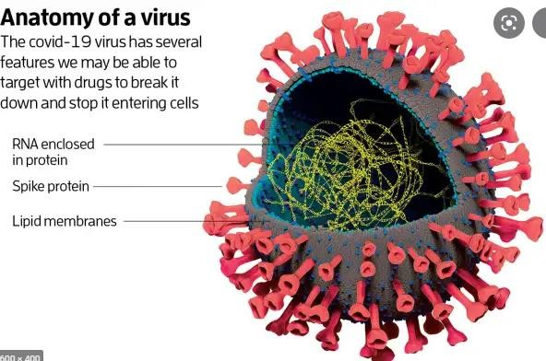
How Viruses Invade Your Body  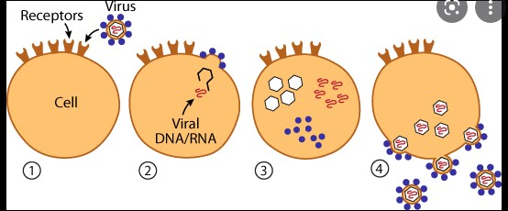 | Viruses are everywhere. They float in the air. Some Corona viruses do nothing to us. Other corona viruses give us a cold but some Corona viruses like SARS make people very sick.  There are many different viruses that cause colds and flus.  If we catch a cold/flu the virus causing the illness gets into our cells and uses its genetic code to make thousands of copies of itself. It then bursts out of the cell, killing it and going on to infect thousands of other cells, and so on.
How Antibodies Fight Viruses  Our immune system recognizes that the virus is different. It makes antibodies to fight it.  The antibodies kill the virus.  If you have not come across this virus before, it takes several days for your body’s immune response to get going. In this time you will become ill, perhaps seriously, and could even die.  COVID19 is a new virus so none of us have any immunity to it. |  |  |  | 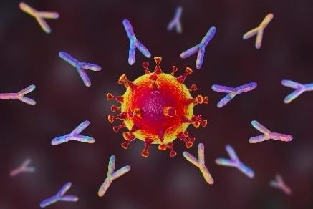
 |  |  |  |  | Antibodies attacking the virus
The Covid Vaccine  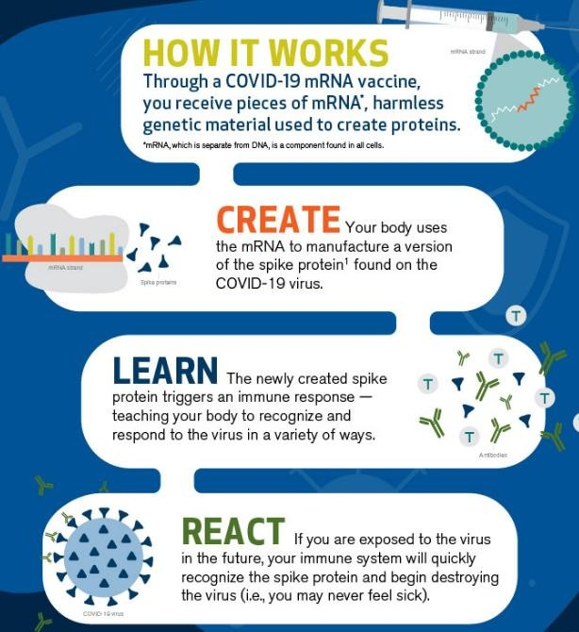 |  | How it Works  It contains mRNA which is a harmless messenger which tells the cells to make spike protein. The mRNA is kept stable with a mixture of fats, salts and sugar.  Create  When you are vaccinated the mRNA tells your cells to make the spike protein. There is no active virus or viral genetic material in the vaccine.  The mRNA then dies. It never enters the nucleus where your DNA is stored.  Learn  The body’s immune system learns to make antibodies to kill the spikes.  React  If you catche Corona-virus, you already have the antibodies that quickly recognizes the spikes and kills the virus before it can make millions of copies of itself. This stops you getting sick.

WHAT’s IN THE Pfizer Vaccine
- mRNA (with instructions to make the spike protein)
- lipids (fats)
- potassium phosphate, sodium phosphate, potassium chloride and sodium chloride, Potassium, sodium and phosphate all occur naturally in our body.
- sucrose, or table sugar

NOT IN PFIZER VACCINE
Eggs, latex, covid virus, DNA, preservatives, antibiotics, mercury, aluminum, fetal parts or computer chips.

SIDE EFFECTS:
These are due to your body’s immune system reacting.
- Allergic reactions may happen shortly after receiving the vaccine – you will be required to wait 15mins. This is why it is given by health professionals who are skilled/trained with dealing with allergic reactions.
- Other things people have allergic reactions to are medications, beestings, peanuts, seafood, pollens etc.
- A sore arm, a headache or feeling fluey for a day or two is the most common. This is a sign that your immune system is reacting strongly and giving you good immunity.
- A very rare side effect of the Pfizer vaccine is inflammation of the heart (myocarditis) or the membrane surrounding the heart (pericarditis).
These conditions sometimes occur after a viral illness, and are usually mild, but sometimes severe. They occur much more frequently after COVID19 illness. You are 18 times more likely to get myocarditis or pericarditis after getting sick with COVID19 than after the vaccine. This is on top of the other complications that COVID19 illness causes such as blood clots, strokes, heart attacks, damaged lungs, “long covid” and so on.
Doctors are on the alert for side effects, and if you experience any chest pain, shortness of breath or palpitations after receiving the vaccine, please contact your doctor.

For further information please go to the following site:

https://www.health.govt.nz/our-work/diseases-and-conditions/covid-19-novel-coronavirus/covid-19-vaccines If you need more information or please contact Your practice nurse or GP

